[ Insert official UPAEP logo ]
UPAEP · Decanato de Ingenierías
EVIDENCE — US15-T1
Design the actuator command flow
SmartGreenAI: Cilantro Crop

1. Task information
Task ID | US15-T1
User Story | US-15 — Manually activate or deactivate irrigation
Sprint | Sprint 3 (2026-10-12 – 2026-10-30)
Week | Week 1
Responsible | Vicente Rocha Alfaro
Peer reviewer | Oscar Abraham Talavera Nava
Planned / actual hours | 1 h / 1 h
Completed on | October 16, 2026
Status | Done

2. Task description
Draw the sequence diagram: web app → API → command queue → device polls pending commands → executes → reports the new state. Define the command states PENDING, SENT, EXECUTED, FAILED and EXPIRED.

3. Completion conditions
✓ Condition 1: Sequence diagram created.
How it was verified: Sequence diagram: web app → API → command queue (actuator_commands) → the device polls pending commands → executes → reports the new state.
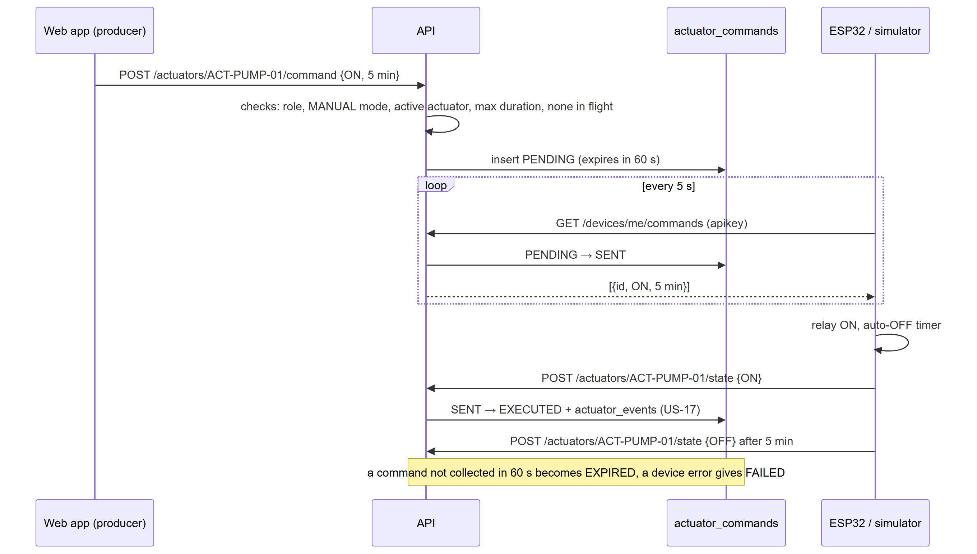
Figure US15-T1-1. Sequence diagram of the actuator command flow. (US15-T1_Design_Actuator_Command_Flow_1.png)
✓ Condition 2: Command states defined.
How it was verified: Command states: PENDING (queued), SENT (collected by the device), EXECUTED (state confirmed), FAILED (device error), EXPIRED (not collected within command.expiry_seconds = 60 s).
Command states enforced by the database (3 rows; US15-T1_Design_Actuator_Command_Flow_2.csv)
conname | definition
actuator_commands_action_check | CHECK ((action = ANY (ARRAY['ON'::text, 'OFF'::text])))
actuator_commands_source_check | CHECK ((source = ANY (ARRAY['MANUAL'::text, 'AUTOMATIC'::…
actuator_commands_status_check | CHECK ((status = ANY (ARRAY['PENDING'::text, 'SENT'::text…
SQL: SELECT conname, pg_get_constraintdef(oid) AS definition FROM pg_constraint WHERE conrelid = 'actuator_commands'::regclass AND contype = 'c'
Command states
State | Set when
PENDING | the API accepts the command
SENT | the device collects it with GET /devices/me/commands
EXECUTED | the device reports the new state
FAILED | the device reports it could not execute it
EXPIRED | nobody collected it within 60 s (alertResolver job)

✓ Condition 3: Flow agreed with Oscar (US-16) and Carlos (US-17).
How it was verified: The flow was agreed with Oscar (automatic irrigation creates commands through the same flow) and Carlos (every executed command writes an event).
✓ Condition 4: Evidence: Sequence diagram approved by the team.
How it was verified: Sequence diagram approved by the team.

4. Attached files
- US15-T1_Design_Actuator_Command_Flow_1.png
- US15-T1_Design_Actuator_Command_Flow_2.csv
- US15-T1_Design_Actuator_Command_Flow_3.sql

5. Traceability
Related requirements | FR-16, FR-17
Implementation | docs/ARCHITECTURE.md actuation sequence diagram; schema.sql → actuator_commands
Verification | —

6. Sign-off
Role | Name | Date | Signature
Responsible | Vicente Rocha Alfaro | October 16, 2026
Peer reviewer | Oscar Abraham Talavera Nava | October 16, 2026
Product Owner acceptance | Alexis Enrique Valle Parra | October 16, 2026
Approval record: Daily Meeting 2 of Sprint 3 (Monday, October 19, 2026), Scrum board: "Tasks moved to Done last week: US11-T1, US11-T2, US12-T1, US13-T1, US13-T2, US15-T1, US15-T2, US15-T3, US15-T4, US15-T5 (early), US16-T1, US16-T2, US17-T1, US19-T1, US19-T2, US19-T3." Daily Meeting 1: "The device will poll pending commands every 5 s."

